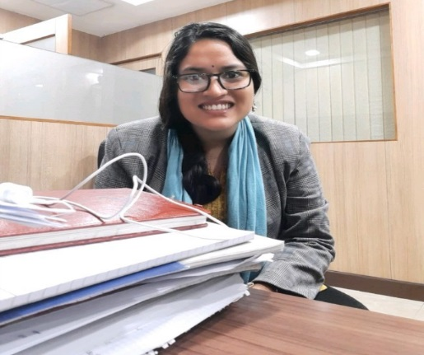

ESTEEM PROJECTS PVT LTD | 6 MONTHS

GL BAJAJ INSTITUTE| 7 MONTHS

GEOCONINFRA PVT LTD | 6 MONTHS

Worked in Bore log preparations, sieve analysis and report preparation of Highways, sewer lines and Building projects Axial load capacity and Lateral load capacity of Pile Foundation. Bearing capacity. Settlement, soil profile, index properties calculation

TRAINING AND PROJECTS

Worked in bearing capacity settlement liquefaction calculations of RE wall. Ground improvement technique calculation and RE wall design calculation according to codal provision and Marketing work

ASSISTANT PROFESSOR

EXPLORE ENGG CONSULTANTS PVT LTD |4 MONTHS

ARCHANA RAWAT

* Alaknanda Hydro Power Project Dam site visit.
* Multi-storeyed building design in ETABS training in CSi Delhi, Design and analysis of G+2 building in CPWD
* Soil-Structure Interaction Project in Abaqus.
* FDP on Urban Infrastructure and Tunnel site visit, GIAN Prog on Geosynthetics and Geotech Structures.

GEOTECHNICAL ENGINEER

Taught Concrete Technology, Structural Health Monitoring and environmental engineering subjects. Worked in NBA work

Worked in modeling and dynamic analysis of Fired heater and its components using is800 and API 560. Structural report preparation and steel Design and detailing work Documentation work contains dimensional parameters and design philosophies

GEOTECHNICAL ENGINEER

HOBBIES: TRAVEL |SPORTS|READING PHOTOGRAPHY|DANCE

REFERENCES

DTU| PROFESSOR

DTU | PROFESSOR

COLONEL KC TIWARI

DR. ASHUTOSH TRIVEDI

https://www.linkedin.com/in/archana-rawat-111868167/

XTH 2008 PERCENT 93.6%

XIITH 2010 PERCENT 91.8%

KENDRIYA VIDYALAYA CHD

PU-CCET 2010-2014

BE CIVIL (8.5 CGPA)

Seeking a position of GEOTECHNICAL ENGINEER to work in a fast-paced and challenging environment where solid analytical and quantitative skills accompanied with a strong passion for industry can be put to use for the success of the organization

**CONTACT INFO**

Phone

+91 9971097330

Email

rawat.1111archana@gmail.com

Web

**EDUCATION**

DTU 2014-2016

MTech Geotechnical (8.1CGPA)

**SOFTWARE SKILLS**

MICROSOFT OFFICE

ABAQUS

ETABS

STAAD.PRO

WORK EXPERENCES

STRUCTURAL ENGINEER

GEOTECHNICAL ENGINEER